# THEORY :

The SQL commands that deal with the manipulation of data present in the database belong to DML or Data Manipulation Language and this includes most of the SQL statements. It is the component of the SQL statement that controls access to data and to the database. Basically, DCL statements are grouped with DML statements.

List of DML commands:

* **SELECT :** This command is used to retrieve data from one or more tables in the database. We can use this command to filter and sort data based on specific criteria.
* **INSERT :** This command is used to add new data into a table in the database. We can insert one or more rows of data into a table at a time.
* **UPDATE :** This command is used to modify existing data in a table in the database. We can update one or more rows of data at a time.
* **DELETE :** This command is used to delete data from a table in the database. We can delete one or more rows of data at a time.
* **JOIN :** This command is used to combine data from two or more tables in the database. We can use various types of joins, such as INNER JOIN, LEFT JOIN, and RIGHT JOIN, to combine data based on specific criteria.

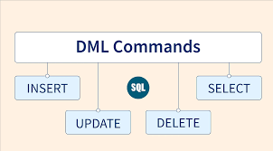

# CODE :

## Table 1.

INSERT INTO Client_master VALUES('C00001','Ivan Bayross','Bombay','Maharashtra','400054',15000); INSERT INTO Client_master VALUES('C00002','Vandana Saitwal','Madras','Tamil Nadu','780001',0); INSERT INTO Client_master VALUES('C00003','Pramada Jaguste','Bombay','Maharashtra','400057',5000); INSERT INTO Client_master VALUES('C00004','Basu Navindgi','Bombay','Maharashtra','4000546',0); INSERT INTO Client_master VALUES('C00005','Ravi Sreedharan','Delhi','','100001',2000);

INSERT INTO Client_master VALUES(‘C00006','Rukmini','Bombay','Maharashtra','400050',0);

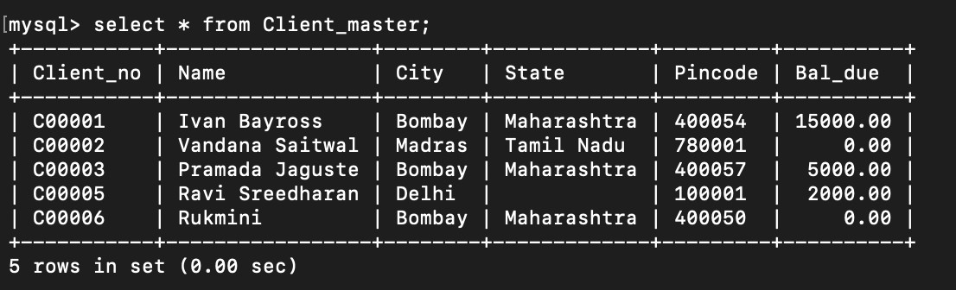

## Table 2.

INSERT INTO Product_master VALUES('P00001','1.44 Floppies',5,'Piece',100,20,525,500);

INSERT INTO Product_master VALUES('P03453','Monitors',6,'Piece',10,3,12000,11280); INSERT INTO Product_master VALUES('P06734','Mouse',5,'Piece',20,5,1050,1000); INSERT INTO Product_master VALUES('P07865','1.22 Floppies',5,'Piece',100,20,525,500);

INSERT INTO Product_master VALUES('P07868','Keyboards',2,'Piece',10,3,3150,3050); INSERT INTO Product_master VALUES('P07885','CD Drive',2.5,'Piece',10,3,5250,5100); INSERT INTO Product_master VALUES('P07965','540 HDD',4,'Piece',10,3,8400,8000); INSERT INTO Product_master VALUES('P07975','1.44 Drive',5,'Piece',10,3,1050,1000);

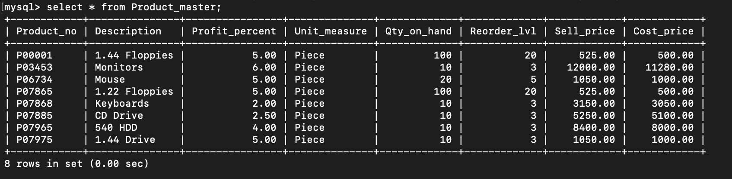

INSERT INTO Product_master VALUES('P07965','1.22 Drive',5,'Piece',2,3,1050,1000);

## Table 3.

INSERT INTO Salesman_master VALUES('S00001','Kiran','A/ 14','Worli','Bombay','400002','MAH',3000,100,50,'Good');

INSERT INTO Salesman_master VALUES('S00002','Manish','65','Nariman','Bombay','400001','MAH',3000,200,100,'Good');

INSERT INTO Salesman_master

VALUES('S00003','Ravi','P-7','Bandra','Bombay','400032','MAH',3000,200,100,'Good');

INSERT INTO Salesman_master VALUES('S00004','Ashish','A/ 5','Juhu','Bombay','400044','MAH',3000,200,150,'Good');

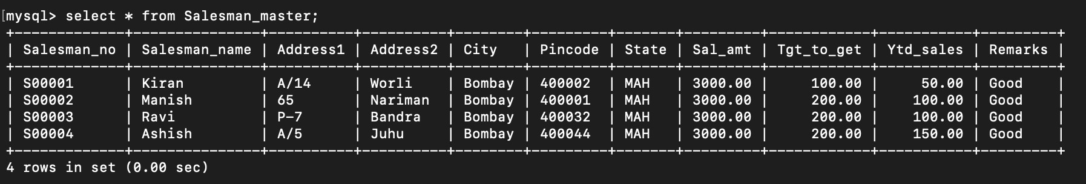

## Table 4.

INSERT INTO Sales_order VALUES('O19001','1996-01-12','C00001','Bombay','S00001','F','N','1996-01-20','IN PROCESS');

INSERT INTO Sales_order

VALUES('O19002','1996-01-25','C00002','Madras','S00002','P','N','1996-01-27','CANCELLED');

INSERT INTO Sales_order

VALUES('O46865','1996-02-18','C00003','Bombay','S00003','F','Y','1996-02-20','FULFILLED');

INSERT INTO Sales_order

VALUES('O19003','1996-04-03','C00001','Bombay','S00001','F','Y','1996-04-07','FULFILLED');

INSERT INTO Sales_order

VALUES('O46866','1996-05-20','C00004','Bombay','S00002','P','N','1996-05-22','CANCELLED');

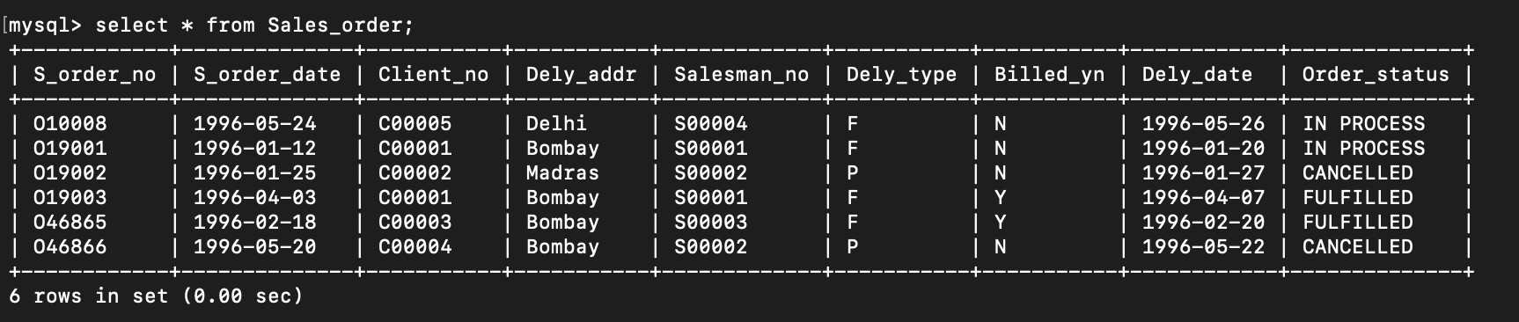INSERT INTO Sales_order VALUES('O10008','1996-05-24','C00005','Delhi','S00004','F','N','1996-05-26','IN PROCESS’);

## Table 5.

INSERT INTO Sales_order_details VALUES('O19001','P00001',4,4,525); INSERT INTO Sales_order_details VALUES('O19001','P07965',2,1,8400); INSERT INTO Sales_order_details VALUES('O19001','P07885',2,1,5250); INSERT INTO Sales_order_details VALUES('O19002','P00001',10,0,525); INSERT INTO Sales_order_details VALUES('O46865','P07868',3,3,3150); INSERT INTO Sales_order_details VALUES('O46865','P07885',3,1,5250); INSERT INTO Sales_order_details VALUES('O46865','P00001',10,10,525); INSERT INTO Sales_order_details VALUES('O46865','P03453',4,4,1050); INSERT INTO Sales_order_details VALUES('O19003','P03453',2,2,1050); INSERT INTO Sales_order_details VALUES('O19003','P06734',1,1,12000); INSERT INTO Sales_order_details VALUES('O46866','P07965',1,0,525); INSERT INTO Sales_order_details VALUES('O46866','P07975',1,0,8400); INSERT INTO Sales_order_details VALUES('O10008','P00001',10,5,525); INSERT INTO Sales_order_details VALUES(‘O10008','P07975',5,3,1050);

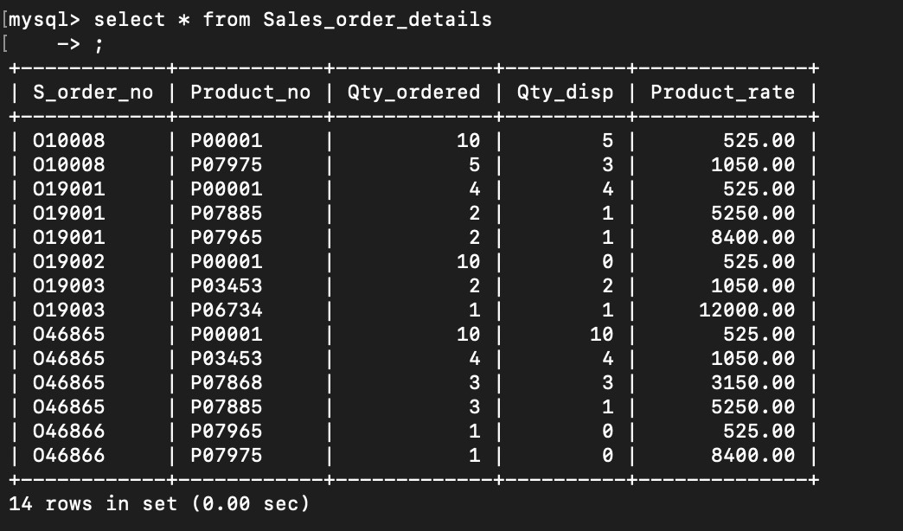

## Table 6.

INSERT INTO Challan_Header VALUES('CH9001','O19001','1996-12-12','Y'); INSERT INTO Challan_Header VALUES('CH6865','O46865','1995-11-12','Y'); INSERT INTO Challan_Header VALUES(‘CH3965','O10008','1995-10-12','Y');

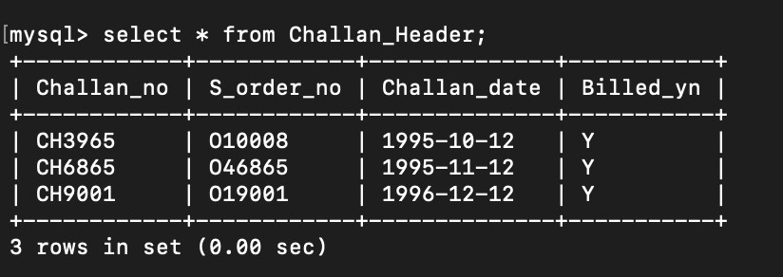

## Table 7.

INSERT INTO Challan_Details VALUES('CH9001','P00001',4); INSERT INTO Challan_Details VALUES('CH9001','P07965',1); INSERT INTO Challan_Details VALUES(‘CH9001','P07885',1); INSERT INTO Challan_Details VALUES('CH6865','P07868',3); INSERT INTO Challan_Details VALUES('CH6865','P03453',4); INSERT INTO Challan_Details VALUES('CH6865','P00001',10); INSERT INTO Challan_Details VALUES('CH3965','P00001',5); INSERT INTO Challan_Details VALUES('CH3965','P07975',2);

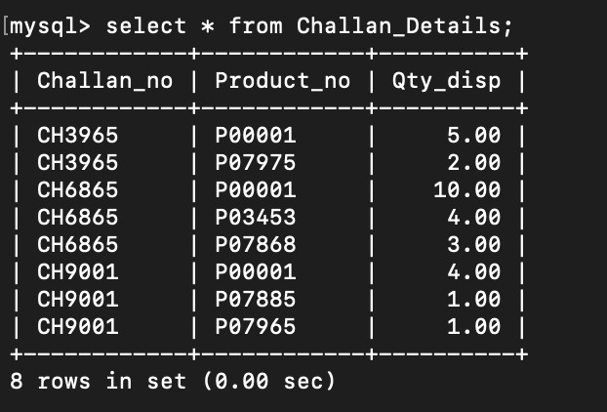

**CONCLUSION -** LO2 Mapped.